Kindergarten-1st Grade Choice Board, Movements 8-9

Either movement may be completed first.

Movement 8 | Movement 9
Part 1: Watch “Musicograma de la Marxa de Radetzky - Johann Strauss” https://www.youtube.com/watch?v=Bb56fQ9WrWM. At the beginning, march when you see the marching man dressed in red. Then perform the quarter note/quarter note/eighth/eighth/quarter note pattern using patting and clapping as they show you. Watch the conductor’s baton and it will track for you. When you see pictures of hands, move your hands with the music. Oh, be ready to crash the cymbals too! The music will change from one section to another, so be ready to switch from one movement pattern to another! You’ll be great!  Part 2: Watch either“Danza de los Caballeros Percusión corporal” https://www.youtube.com/watch?v=JtjwWc_omFA or “Dance of the Sugar Plum Fairy Rhythm Challenge” https://www.youtube.com/watch?v=WIxq-1a_810&t=62s. In both of these videos you will perform quarter notes, quarter rests, and beamed eighth notes.The “Danza” video will show you which motions to perform and when to perform them. You will use patting, clapping, pounding right or left fists, and pounding fists together. Be careful to clap twice on the beamed eighth notes, and watch out to perform nothing for the quarter rests! You can perform the “Dance of the Sugar Plum Fairy” by clapping, patting, tapping, or any other body percussion. I think it would be fabulous to tiptoe to perform the eighth notes and quarter notes. Be sure to do nothing on the individual quarter rests! When you get to the many quarter rests in the middle, pretend to strum sounds on a harp. | Have you ever heard of Flat Stanley? (He’s a famous character in the book series Flat Stanley’s Worldwide Adventures by Jeff Brown.) Well, you are about to meet Flat Beethoven! Ludwig van Beethoven, a composer who lived from 1770 to 1827, composed some beautiful, world-famous music even though he became deaf. You can read a short biography [Link is on ‘Directions’ page on web site.] that tells more about him. NowFlat Beethoven was cleaning up after an orchestra rehearsal when he was ‘squished’ after several huge piles of conductors’ scores fell on him; you see he was unable to hear them falling, so he could not move out of their way. Flat Beethoven’s accident is unfortunate, but now he has the ability to go anywhere and slip through tiny openings where he could not travel before. Now that he—in the form of a “Flat Beethoven Template” [Link is on ‘Directions’ page on web site.]—is in your hands, you can help him see even more sights—hopefully, some that are even a bit musical! You could even introduce him to some ‘newer’ (since his lifetime) kinds of music and instruments that are used to perform now. Keep a written journal or a photo journal of his travels! I’d love to see some of his adventures!  You also might want to watch some videos that are related to Mr. Beethoven:  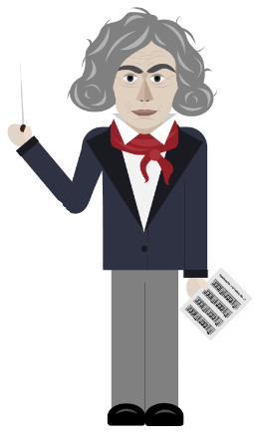  “Beethoven According to Peanuts” https://www.youtube.com/watch?v=kuQBjuySvyw  “Sarah’s Music: Beethoven for Kids! - with Sarah Willis”https://www.youtube.com/watch?v=_O9bwvGfsKs  “Celebrating Ludwig van Beethoven’s 245th Year Google Doodle” https://www.youtube.com/watch?v=S1tY1QGIAqg  “Peabody’s Improbable History – Ludwig von Beethoven”https://www.youtube.com/watch?v=mnmiwo79aTg

