Ice Chalk

Ice chalk is a simple mixture of cornstarch, water, and food coloring or watercolor paint. Simply mix these ingredients together and freeze for cooling fun on a warm afternoon. It can be easily washed away with a little water (more temporary than traditional sidewalk chalk) and can be made with ingredients from around the house.

Materials:
1 cup of cornstarch
1 cup of warm water
Ice pop tray or ice tray with optional popsicle/craft sticks
Mixing bowl
Spoon
Food coloring or watercolor paint

Process:
- Combine cornstarch with warm water and mix thoroughly.
- Pour the mixture into ice pop trays or ice trays; prepare to freeze.
- Add food coloring or a liquid watercolor of choice to the mixture. Encourage bright and fun colors, or mix them together and experiment.
- Freeze the mixture until it hardens. Once frozen solid, remove the pieces of ice chalk from the trays and begin drawing.

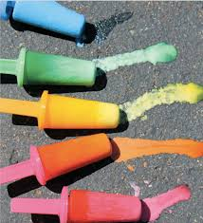

Source:
https://www.kaplanco.com/ii/ice-chalk-art?CategoryID=30

