Homemade Sidewalk Chalk

Flour and eggshells—two basic ingredients from the kitchen—make this chalk recipe very accessible for most people. Cooking and creativity are all rolled into one!

Materials:
Approximately 5 empty eggshells
1 teaspoon flour
1 teaspoon very hot water
Food coloring (for colored chalk)
2 bowls
Spoon

Process:
- Wash and dry the eggshells. Remove any membrane from the inside of the shells.
- Crush the eggshells into a bowl and grind them until they produce a powder. Make sure all the pieces are ground. Take out any big pieces before continuing. [A food processor, blender, or mortar and pestle may prove more efficient than a bowl and spoon alone.]
- Mix the flour and hot water in another bowl.
- Add 1 tablespoon eggshell powder and mix into a thick paste.
- Add a drop or two of food coloring if colored chalk is desired. Do not add any food coloring if white chalk is preferred.
- Shape the paste into long sticks for a traditional chalk shape; roll the sticks up tightly in a paper towel. If fun shapes are wanted, the chalk paste can be shaped free-hand or pressed into soap molds.
- Let the chalk dry for 3 days.
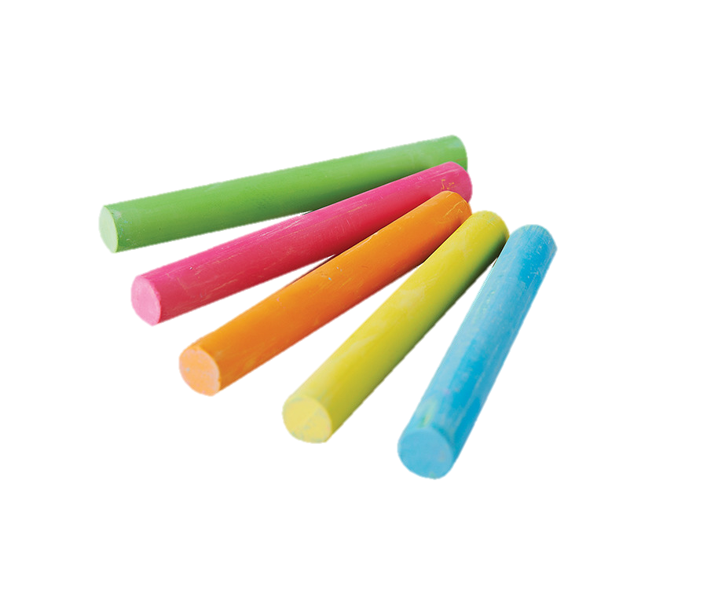

Source:
https://www.thriftyfun.com/Homemade-Sidewalk-Chalk-1.html

