2nd Grade Choice Board, Movements 1-2

Complete Movement 1 before Movement 2. Complete the parts within each movement in order.

Movement 1 | Movement 2
Part 1: Watch “The Music Show Episode #2: I’ve Got Rhythm” https://www.youtube.com/watch?v=RYsGlNpx2YI&t=28s. This video focuses on the notes. What is the difference between beat and rhythm? How many beats is a quarter note? A half note? A Whole note? An eighth note? Replay the video multiple times (Song starts at 3:10.) so that you can sing the song “I’ve Got Rhythm” with it. Clap or pat the quarter note, half note, whole note, and combined-note rhythms. Pay attention to the ways to count quarter notes, half notes, whole notes, and eighth notes. (In class we have used the tas, ti-tis, and ta-ahs. It is also good to know the 1-2-3-4s.)  Part 2: Watch “The Music Show Episode #3: Take a Rest” https://www.youtube.com/watch?v=vo-PBf_WH54. This video focuses on the rests. What are you supposed to do when you see a rest? How many beats is a quarter rest? A half rest? A whole rest? Replay the video multiple times (Song starts at 3:12.) so that you can sing the song “Take a Rest” with it. During the rests, hold your hands palm up and pulse the beats silently.  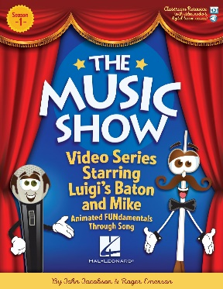 | Part 1: Watch “Introduction to Rhythm: Stage Two” [Visual Musical Minds] https://www.youtube.com/watch?v=cHad-I5AJT0&t=32s. It focuses on quarter notes, eighth notes, and half notes. There are 7 rhythm patterns. You will perform each pattern 4 times by speaking and moving; a trumpet fanfare will signal you to begin each pattern. Play the entire video 3 times so that you perform all 7 patterns by clapping the first time, patting the second time, and stepping the third time. [Note: This video speaks to-e for half notes instead of ta-ah. It is fine for you to continue using ta-ah for half notes.]  Part 2: Watch “Introduction to Rhythm: Stage Three” [Visual Musical Minds] https://www.youtube.com/watch?v=rf5rcXhGPps. It focuses on quarter notes, eighth notes, half notes, and quarter rests. There are 9 rhythm patterns. You will perform each pattern 4 times by speaking and moving; a double bass melody will signal you to begin each pattern. Play the entire video 3 times so that you perform all 9 patterns by clapping the first time, patting the second time, and stepping the third time. Have fun, but be accurate with the rests—no sound and no fudging! [Note: Again, it is fine for you to continue using ta-ah for half notes.] You’ve got this!  Part 3: Watch “Introduction to Rhythm Reading: Bonus Reading: Bonus Challenge” [Visual Musical Minds] https://www.youtube.com/watch?v=yTUXC_O2FI8&t=32s. It also focuses on quarter notes, eighth notes, half notes, and quarter rests. There are 8 rhythm patterns. You will perform each pattern 4 times by speaking and moving; a melody plucked by the violin will signal you to begin each pattern. Play the entire video 3 times so that you perform all 8 patterns by clapping the first time, patting the second time, and stepping the third time. Have fun, but be accurate with the rests—no sound and no fudging! [Note: Again, it is fine for you to continue using ta-ah for half notes.] You’re a pro!

