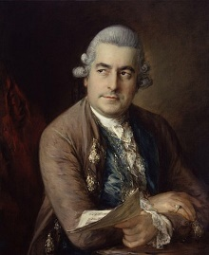  Carl Philipp Emanuel Bach  1714-1788 | 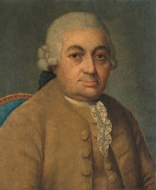  Johann Christian Bach  1735-1782 | 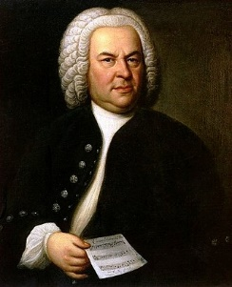  Johann Sebastian Bach  1685-1750 | 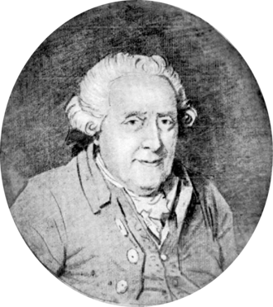  Wilhelm Friedemann Bach  1710-1784
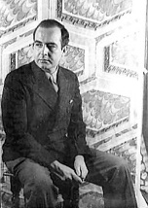  Samuel Barber  1910-1981 | 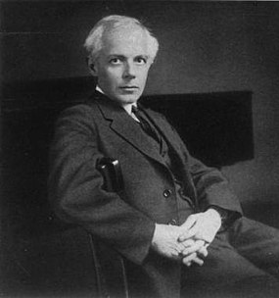  Béla Bartók  1881-1945 | 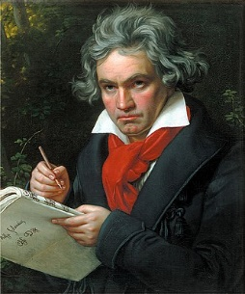  Ludwig van Beethoven  1770-1827 | 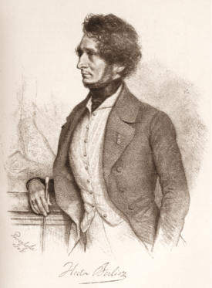  Hector Berlioz  1803-1869
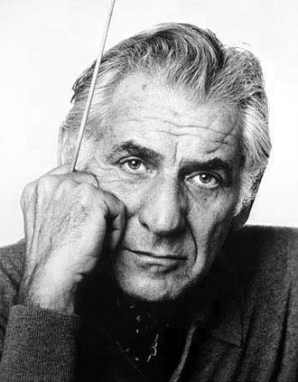  Leonard Bernstein  1918-1990 | 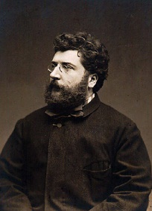  Georges Bizet  1838-1875 | 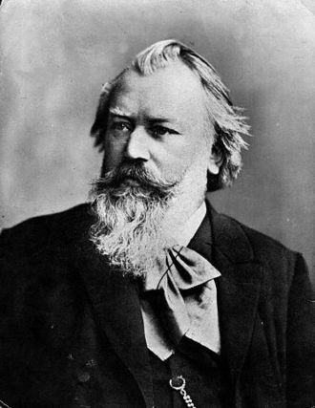  Johannes Brahms  1833-1897 | 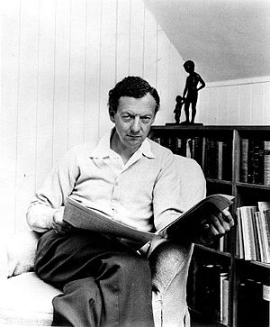  Benjamin Britten  1913-1976
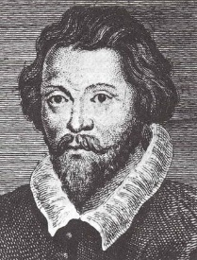  William Byrd  1539/1543-1623 | 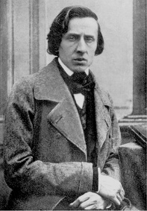  Frédéric Chopin  1810-1849 | 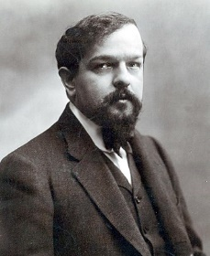  Claude Debussy  1862-1918 | 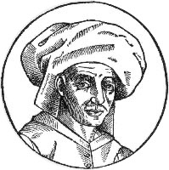  Josquin des Prez  1450/1455-1521
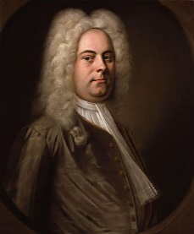  George Frideric Handel  1685-1759 | 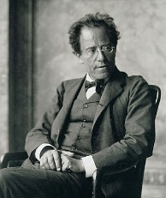  Gustav Mahler  1860-1911 | 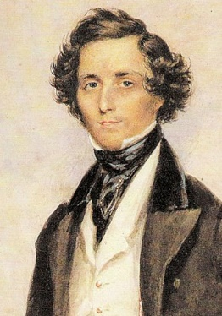  Felix Mendelssohn  1809-1847 | 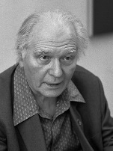  Olivier Messiaen  1908-1992
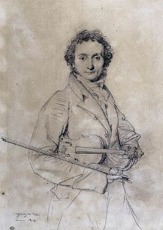  Niccolò Paganini  1782-1840 | 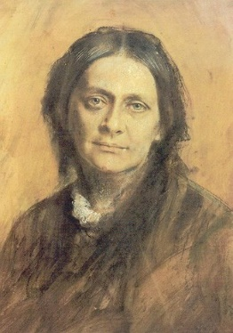  Clara Schumann  1819-1896 | 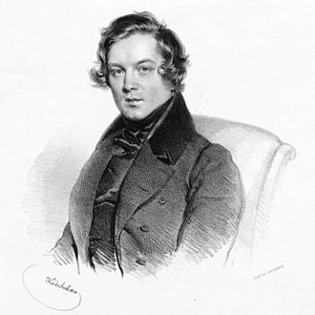  Robert Schumann  1810-1856 | 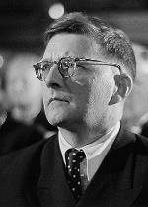  Dmitri Shostakovich  1906-1975
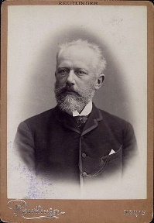

Pyotr Ilyich Tchaikovsky
1840-1893

