Easy Homemade Sidewalk Chalk

Ice chalk is a simple mixture of cornstarch, water, and food coloring or watercolor paint. Simply mix these ingredients together and freeze for cooling fun on a warm afternoon. It can be easily washed away with a little water (more temporary than traditional sidewalk chalk) and can be made with ingredients from around the house.

Materials:
Cardboard tubes (from rolls of paper towels or toilet paper)
Scissors
Duct tape
Freezer paper
Plastic quart containers (recycled deli containers or milk jugs with tops cut off)
Tempera paint in desired colors
Water
Spoon
Plaster of paris
Rubber spatula
Cooling rack

Process:
- Cut paper towel tubes in half or use uncut toilet paper tubes. Tape off one end of each tube with duct tape, being sure to completely seal it.
- Cut freezer paper into 6-inch squares; line each tube with one piece.
- In a plastic container, the plaster of paris will be mixed as directed, in the correct ratio. However, be sure to first mix 2 tablespoons of the desired color of tempera paint with the water used to make the plaster. Mix slowly while adding the plaster to the water/paint mixture, until completely combined.
- Using a rubber spatula, fill each prepared tube with the plaster mixture. Tap each tube on the work surface to release any air bubbles.
- The plaster will set in about an hour and can be removed from the tube after about two hours.
- To remove the chalk from its paper tube mold, first peel away the duct tape; then peel away the cardboard tube, and lastly peel away the piece of freezer paper.
- Once the chalk is removed from the tube, place it on a cooling rack and let it dry completely (1 to 3 days, depending on humidity) before using it.

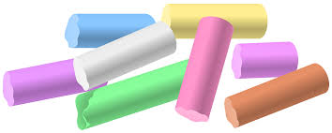

Source:
www.sweetpaulmag.com/crafts/easy-homemade-sidewalk-chalk

