2nd Grade Choice Board, Movements 7-8

Complete Movement 7 before Movement 8. Complete the parts within each movement in order.

Movement 7 | Movement 8
Part 1: Watch “Rhythm Reading Comparison: 4/4 versus 3/4 - Easy Edition” [Visual Musical Minds] https://www.youtube.com/watch?v=GJRItpXDizA. This awesome video demonstrates the difference between 4 beats in a measure and 3 beats in a measure. Watch it one time and follow the high-lighted rhythm symbols. Then perform by speaking and moving (tapping, clapping, patting, etc.) with the video. Hint: After you learn the two basic patterns,the 4-beat pattern is performed 8 times and then the 3-beat pattern is performed 8 times. Then the 4-beat pattern is performed 4 times; the 3-beat pattern is performed 4 times. Guess what. Each pattern is then performed 2 times, and finally the patterns alternate with each measure. Be ready for the surprise at the end!  Part 2: Go to “Classics for Kids” web site https://www.classicsforkids.com/. At the top of the page, click on “Games”. Click on the game “Compose Your Own Music”. Drag the rhythm symbols to the staff to create your own 4-measure melody with 4 beats in each measure. In this activity, when you click on a note value, it will ask you to choose a pitch before it places the note on the staff. If you select a rest, you do not choose a pitch because rests are silent. Be creative!  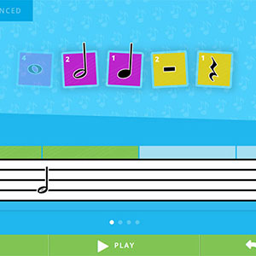 | Part 1: Watch “Rhythm Reading in 3/4 Time” [Visual Musical Minds] https://www.youtube.com/watch?v=MtEkC454tJI&t=39s. This video is a quick review of 3/4 time. You have learned most of the patterns already, but there will be 3 new symbols; by now, you should be able to decode them by watching the high-lighted rhythm symbols and listening carefully. There are 8 rhythm patterns. You will perform each pattern 4 times by speaking and moving; a plucked 6-beat pattern over a shimmery sound will signal you to begin each pattern. Play the entire video 3 times so that you perform all 8 patterns by clapping the first time, patting the second time, and stepping the third time.  Part 2: Go to “Classics for Kids” web site https://www.classicsforkids.com/. At the top of the page, click on “Games”. Click on the game “Match the Rhythm”. Click on “OK, Enter Full Screen”. Let’s see what a good drummer you are! Listen to each rhythm pattern as it is performed. [Hint: Watch for the circles, or note heads, to pass the white barline.] When it is your turn to perform the rhythm, use the mouse to click on the drum set exactly when the circles, or note heads, pass the white barline. Start with the “Beginner” level. If you are successful there, go to the “Advanced” level. If the “Beginner” level was a bit challenging, that is all right; give it another try or two before moving to the “Advanced” level.

